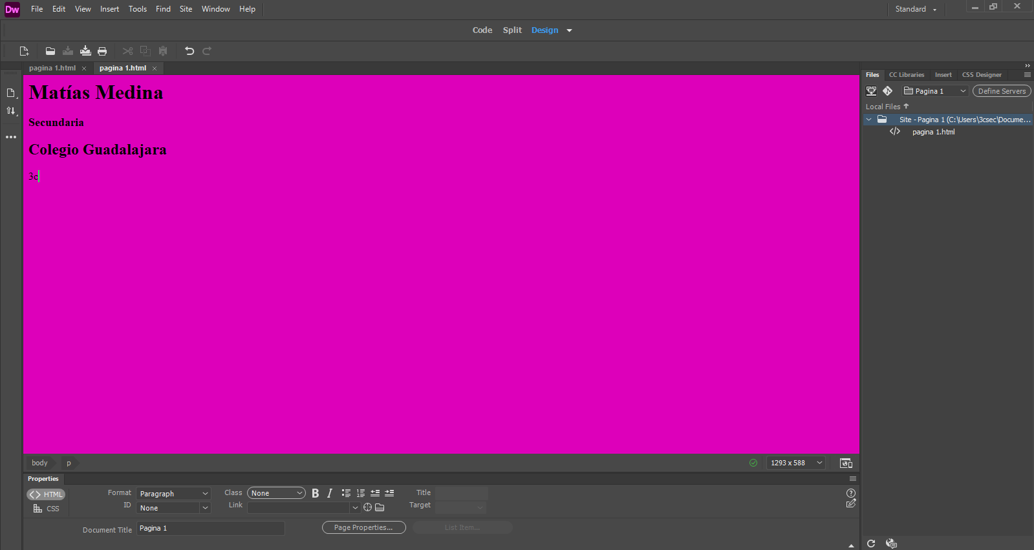
Properties
Insoector tool bar
Insert panels
Document tool bar
Menú bar
Panels
Tool bar
Dreamweaver Layout
workspace

